Employer Information Sheet
New employees: This list represents information about COMPANY NAME as an employer and is required for all new employees in Minnesota. Please review and sign your acknowledgment of receipt below.
- Employee: |  |  |  |  |  | Address:
Phone number: |  |  |  |  |  | Email address:
Date employment began: |  |  |  |  |  | Job Title:
- Legal name of employer: |  |  |  |  |  | - Main office/Principal place of business address:
Phone number: |  |  |  |  |  | Email address:
- 3. Employment status (exempt or non-exempt):
☐ Employee is exempt from: ☐ minimum wage ☐ overtime ☐ other provisions of Minnesota Statutes 177
Legal basis for exemption:
☐ Employee is non-exempt (entitled to overtime, minimum wage, other protections under Minn. Stat. 177)
- Rate: $ |  | Additional rates (if applicable): |  |  |  |  |  | How applied:
Paid by: | Hour ☐ | Salary ☐ |  | Other method ☐
Overtime is owed after: hours
Allowances claimed:
- Leave benefits available:
☐ Personal Time Off (PTO) ☐ Sick and Safety Time (SST) ☐ Other paid time off:
PTO:
SST:
Other:

Terms of use:
- Deductions that may be made from employee’s pay and amounts:
Deductions that may be made from employee’s pay and amounts: taxes, child support and garnishments as required by state, federal and local law. Elected retirement contributions. Benefit premiums for elected benefits

- Number of days in the pay period: |  |  |  |  |  |  | Regularly scheduled payday:
Date employee will receive first payment of wages earned:
- Other information relevant to this position:

I, the employee, have received a copy of this notice: ☐ Yes ☐ No
Employer signature |  |  | Date |  | Employee signature |  |  |  | Date

This document contains important information about your employment. Check the box at left to receive this information in this language.
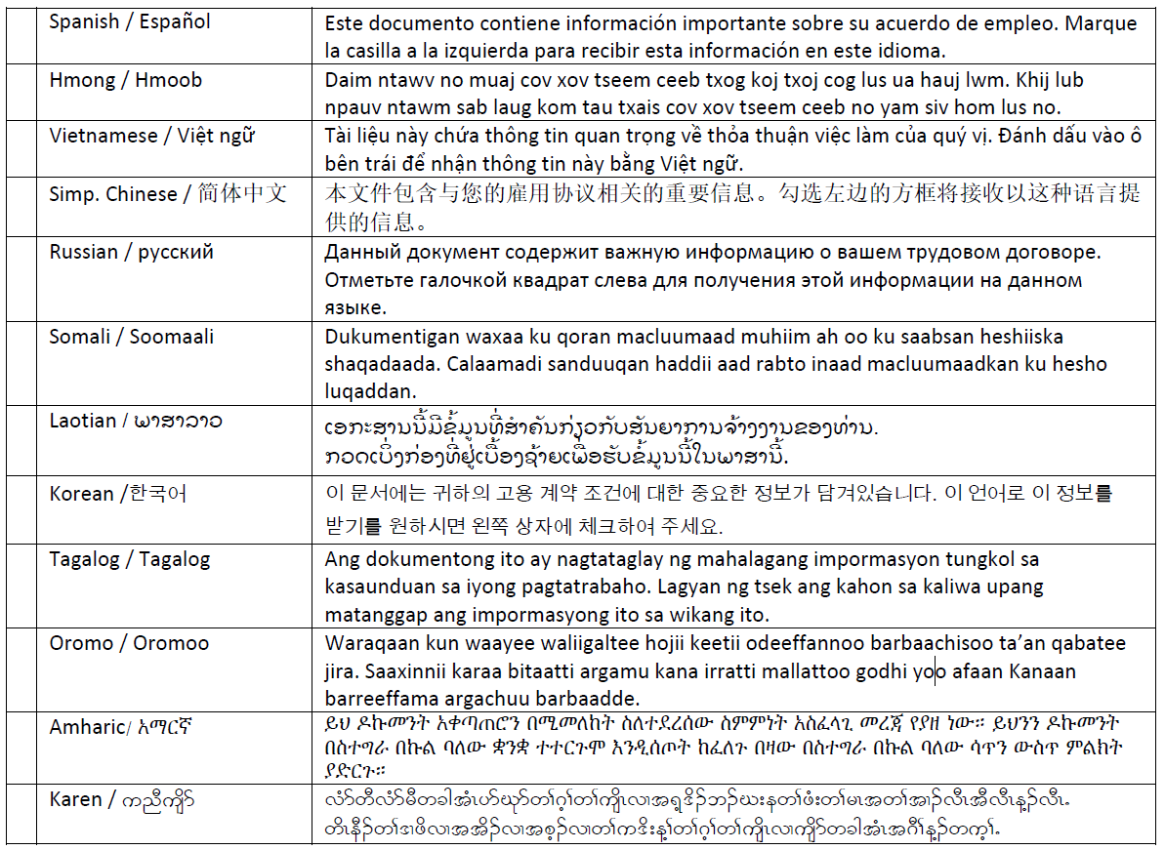

Translation providers approved by the Minnesota Department of Administration
Betmar Languages, Inc. The Bridge World Language Center, Inc. Fox Translation Services
6260 Hwy. 65 N.E., #308 110 Second Street S., #213 1152 Mae Street, #122
Minneapolis, MN 55432 Waite Park, MN 56387 Hummelstown, PA 17033
763-572-9711 320-259-9239 866-369-1646 or 407-733-3720
best@betmar.com mini@bridgelanguage.com dina@foxfoxcasemanagement.com
Global Translation and Interpreter Latin American Translators Network, Inc. Latitude Prime, LLC
913 E. Franklin Ave., #206 1720 Peachtree Street N.W., #532 80 S. Eighth Street, #900
Minneapolis, MN 55404 Atlanta, GA 30309 Minneapolis, MN 55402
612-722-1244 800-943-5286, ext. 8641 888-341-9080, ext. 501
sandor@globaltranslations.com translations@latn.com elle@latitude.com
Lingualinx Language Solutions, Inc. Prisma International, Inc. Swits, LTD
433 River Street, #6001 1128 Harmon Place, #310 110 S. Third Street
Troy, NY 12180 Minneapolis, MN 55403 Delavan, WI 53115
518-388-9000 612-349-3111 262-740-2590
abartlett@lingualinx.com jromano@prisma.com translations@swits.us

